**IMU**

* **Definition:**

IMU stands for (Inertial Measurement Unit). An IMU is a specific type of sensor that measures angular rate, force, and sometimes magnetic field. IMUs are composed of a 3-axis accelerometer and a 3-axis gyroscope, which would be considered a 6-axis IMU. They can also include an additional 3-axis magnetometer, which would be considered a 9-axis IMU.

* **Operation Principle:**

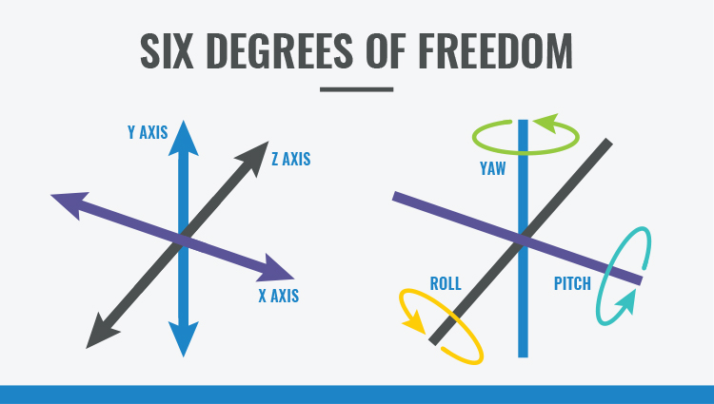An IMU provides 2 to 6 DOF (Degrees of Freedom), which refers to the number of different ways that an object can move throughout 3D space. The maximum possible is 6 DOF, which would include 3 degrees of translation (flat) movement across a straight plane/along each axis (front/back, right/left, up/down) and 3 degrees of rotational movement across the x, y and z axes/about each axis.

The raw data collected from an IMU gives some idea of the world around it, but that information can also be processed for additional insight. Sensor fusion is the (mathematical) art of combining the data from each sensor in an IMU to create a more complete picture of the device’s orientation and heading. For instance, while looking at gyroscope information for rotational motion, you can incorporate an accelerometers sense of gravity to create a reference frame. You can additionally add information about the Earth’s magnetic field to align the whole sensor to the Earth’s frame.

* **Type of Sensors in IMU:**
* **Accelerometer:** The most used type of motion sensor is the accelerometer. It measures acceleration (change of velocity) across a single axis, like when you step on the gas in your car or drop your phone. Accelerometers measure linear acceleration in a particular direction. An accelerometer can also be used to measure gravity as a downward force. Integrating acceleration once reveals an estimate for velocity and integrating again gives you an estimate for position. Due to the double integration and the state of today’s technology, an accelerometer is not a recommended method of distance estimation.

**Note:** there is something called Kalman filter which give more accurate results but i didn’t dive into it so it require further research.

* **Gyroscope:** While accelerometers can measure linear acceleration, they can’t measure twisting or rotational movement. Gyroscopes, however, measure angular velocity about three axes: pitch (x axis), roll (y axis) and yaw (z axis). When integrated with sensor fusion software, a gyro can be used to determine an object’s orientation within 3D space. While a gyroscope has no initial frame of reference (like gravity), you can combine its data with data from an accelerometer to measure angular position. For an in-depth look at the different types of gyroscopes, look to our 2nd blog titled, Exploring the Application of Gyroscopes.
* **Magnetometer:** A magnetometer, as the name suggests, measures magnetic fields. It can detect fluctuations in Earth’s magnetic field, by measuring the air’s magnetic flux density at the sensor’s point in space. Through those fluctuations, it finds the vector towards Earth’s magnetic North. This can be fused in conjunction with accelerometer and gyroscope data to determine absolute heading. As you’ve seen, IMUs are used to measure acceleration, angular velocity, and magnetic fields, and, when combined with sensor fusion software, they can be used to determine motion, orientation and heading. They’re found in many applications across consumer electronics and the industrial sector.

Reference:

1. What is IMU?

(<https://www.ceva-dsp.com/ourblog/what-is-an-imu-sensor/#:~:text=An%20IMU%20is%20a%20specific,considered%20a%209%2Daxis%20IMU>. ).

1. Connection between IMU and Arduino UNO:

(<https://learn.adafruit.com/adafruit-9-dof-imu-breakout/connecting-it-up> ).

**TTL Serial**

**First: Serial Communications:**

* **Definition:**

Serial Communication is a way for data transfer, transmitting over one wire, one bit, at a time. Involving two parties; Transmitter and Receiver, data transferred is in the form of binary pulses through different methods of serial digital binary.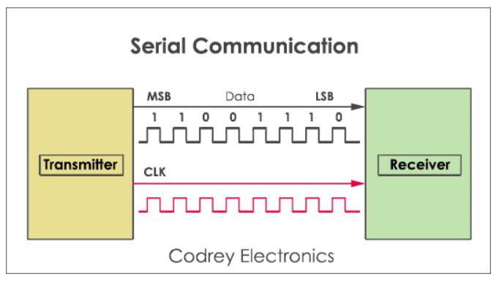

* **Characteristics of Serial Communication:**

**Baud Rate:** Used to measure the speed of transmission, it refers to the number of bits passing in one second. Higher baud rates indicate a higher number of bits per second passed

**Stop Bits** are used for a single packet to stop the transmission denoted as “T”. Typical values are 1, 1.5 & 2 bits.

**Parity Bit:** is a function used to find errors in the data. There are of 4 kinds, i.e., even, odd, marked and spaced.

* **How does Serial Communication work?**
* Serial communicating first involves two serial devices, each having two serial pins: The receiver (RX), The transmitter (TX).
* Both devices are then wired by connecting wires from the master device’s TX to the listener’s RX line
* Devices communicate serially through signal methods, popular ones being TTL serial, RS-232.
* 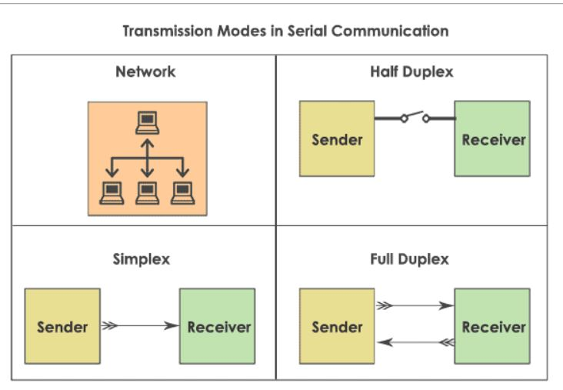**Modes of Communications:**
* **Simplex Method:** One way communication, only the sender or receiver is active at a time. Example: Radio, Television
* **Half-Duplex Mode:** Both the sender and receiver are active but not at a time. If the sender transmits, the receiver can accept but cannot send, vice versa. Example: Internet
* **Full-Duplex Mode (Most commonly used):** Both the sender and receiver can transmit and receive at the same time. Example: Smartphone communication

**Second: TTL Serial**

* **What is TTL Serial?**

TTL stands for Transistor-Transistor Logic, a serial communication commonly found in UART (universally asynchronous receiver/transmitter) transmission method, a method seen in most microcontrollers these days.

We use TTL Module to convert UART into USB that will be connected to Nvidia Jetson.

* **Advantages and Disadvantages of TTL Serial**
* **Advantages:** Low cost, High availability, High compatibility with microcontroller, Ease of usage.
* **Disadvantages:** Noisy, due to poor noise margin, Limited speed and frequency, Higher power consumption at higher frequencies.

**Components used**

**IMU Sensor:**

BNO055 (<https://learn.adafruit.com/adafruit-bno055-absolute-orientation-sensor> ).

**Connections:**

We will use serial UART Communications protocol so we will connect SCL to TX of USB2UART and SDA is connected to RX of USB2UART. The rest pins are left unconnected.

To select UART mode of IMU sensor, PS1 is connected to 3v3 as logic high and PS0 is connected to GND as logic low as shown in the schematic according to table 4-4.

wire used is 1 mm width as current isn’t expected to be more than 1 A

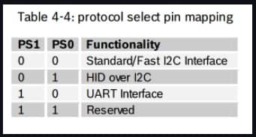

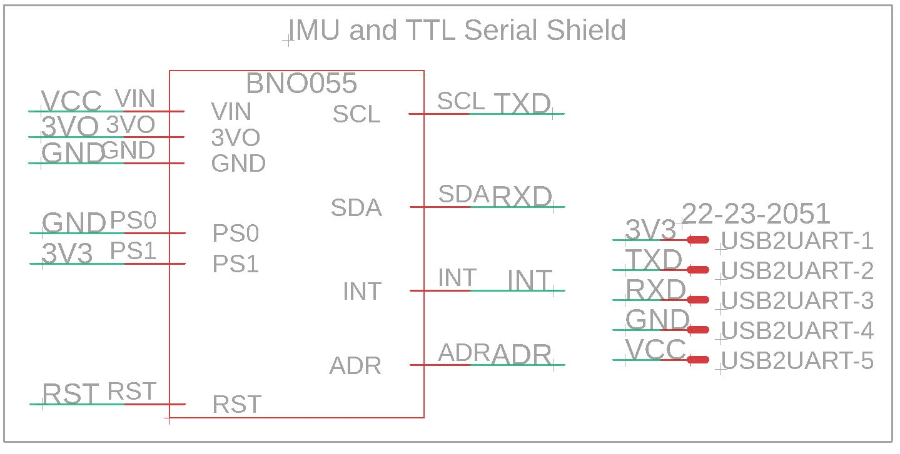

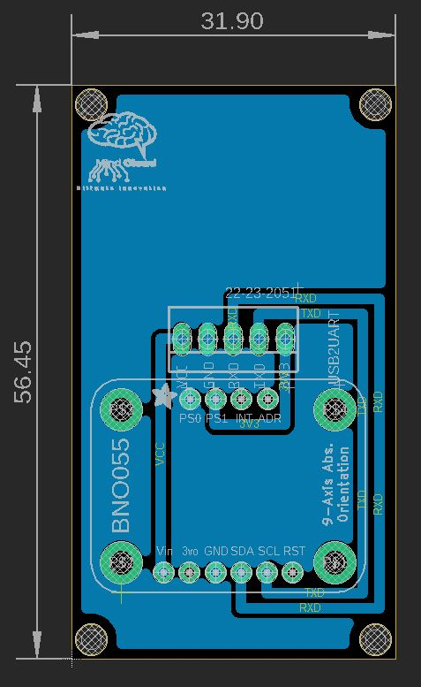

Note: we will use angle female pin header to connect USB2UART module and maintain it fixed

We may increase size of board so that USB2UART is kept within board.

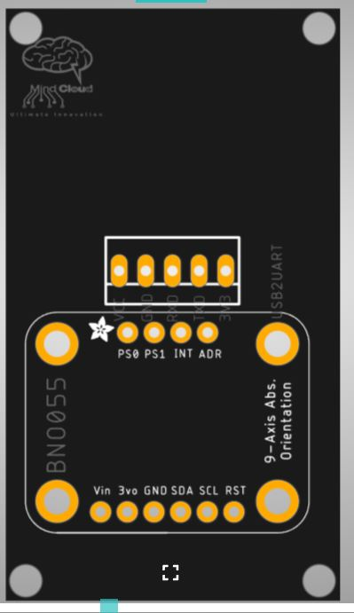Gerber Viewer (<https://www.pcbway.com/project/OnlineGerberViewer.html> )